

**Excel Assignment – 7**

1. Using Insert Function, give examples of any function available in the different dropdowns present in the function library. For example, AutoSum, Recently Used, Text, Date & Time, etc.

Ans: These are different functions in AutoSum: Sum, Average, Maximum, Minimum, Count Numbers and many more.

1. What are the different ways you can select columns and rows?

Ans: Click on the row index (1,2,3..) for row selection and column index(A,B,C..) for column selection.

1. What is AutoFit and why do we use it?

Ans: Autofit is an option in Format (in Home Ribbon) to fit your text/value in cell from height as well as width, so that it is proper visible.

1. How can you insert new rows and columns into the existing table?

Ans: select cell where you want to insert row/column, Go to Home ribbon, Click on insert sheet rows/columns, OR you can right click on selected row index/column index and click insert.

1. How do you hide and unhide columns in excel?

Ans: Click on column index, Go to Home ribbon, select Format, and click Hide & Unhide and then select hide column.

1. 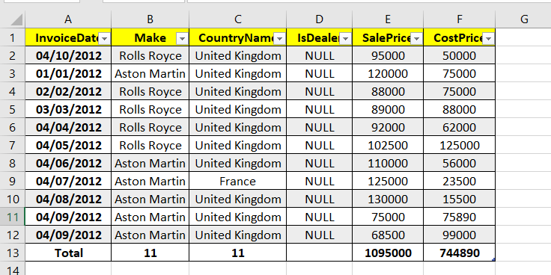Create an appropriate table within the worksheet and use different functions available in the AutoSum command.